

**Near East University**

**Department of Artificial Intelligence**

**Project Management Software for Business Team**

**-** **Ali AL-Radawi**

**- Mustafa AL-Agele**

**The ID of student: -**

* ALI KADHIM student number is (20234737).
* MUSTAFA HMAEED student number is (20234928)

**Summary**

CMS is content management system, and it is a web application that allows a group of users, usually from different departments within an organization, to effectively maintain and organize the content of a website. A Linux Server, Apache Web Server, MySQL Database, and PHP Programming Language are used to create a web-based application.

Project managers require a mechanism to efficiently manage their software projects, and a CMS supports collaboration in the workplace by integrating document management, digital asset management, and records retention functions, as well as offering end users with role-based access to the organization's digital assets.

**Structural of the Study**

**Statement of the Problem**

The Problem addressed in this research is the capacity to establish the key requirements of a CMS for a business team using all technologies with an emphasis on being open object oriented inside a Model View Control/agile framework, to deliver a web-based application that meets the demands of a business and is easy to moderate in the future.

**Definition of Terms**

**Content Management System:** can be defined as a software platform that supports the creation, management, search, distribution, and publication of organizational contents.

**CSS** - Cascading Stylesheets Sheets helps format the look and feel of an HTML document through presentation semantics.

**CRUD** - Create, Reuse, Update, Delete are the four basic functions of a persistent storage implementation.

**HTML** - Hypertext Markup Language, the main language for displaying web content in a web browser.

**JavaScript** – A scripting language that can be considered to implement to add functionality and user enhancements in a web page.

**XAMPP** is an abbreviation for cross-platform, Apache, MySQL, PHP, and Perl, and it allows you to build site offline, on a local web server on your computer.

**OOP** - Object Oriented Programming using class object to extract instances of a section of code when necessary, using techniques like inheritance to different classes logically.

**PHP** - Hypertext Preprocessor is a server side embedded scripting language.

**Feature of web content management system:**

**1. Access control**

it allows managing the user information such as changing the role of the users to (admin, manager, employees) and User groups allow you to controller the registered users relate with the site.

**2. Editable content**

Once content is separated from the visual presentation of a site, it usually becomes much easier and quicker to edit and manipulate.

**3. Scalable features**

WCMS software includes plug-ins or elements that can be easily installed to extend present systems functionality.

**4. Workflow management**

workflow is the process of creating cycles of sequential and parallel tasks that must be skillful in the CMS.

**Working of Web Content Management System:**

A Web content management system uses a programming language to gather the content and the database and then presents it to the clients. There is various script and programming languages can be used in the background of a website. A web content management system is usually run using a database. There are different databases available, and some are only compatible with certain operating systems.A black and white diagram with black text

**Literature Related to the Methodology:**

The Agile Methodology for software development was employed in this project as the methodological approach. The Agile Model is a hybrid of iterative and incremental process models in which cross-functional teams collaborate on planning, requirements analysis, design, coding, unit testing, and acceptance testing during each iteration. This development approach builds each module, adding functionalities every few weeks depending on the requirements, until the project is completed.

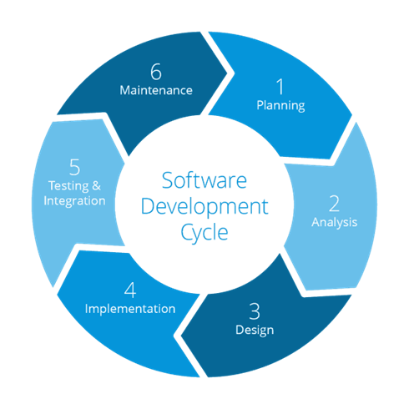

**Database Design and Tools:**

The database is the cornerstone of a software system from a design standpoint. Understanding the nature of the data contained in a system can provide insight into the system's capabilities. Rather than exhibiting the code that produced the database, we built an entity relationship diagram, which depicts the database's structure—the

**PhpMyAdmin** is a free PHP application that assists in the administration of a MySQL server by providing support for a wide range of MySQL server operations.

SQL operations available through the user interface can help manage databases, tables, fields, relations, indexes, user permissions, and even execute SQL syntax statements directly on the MySQL server.

**Advantages of using MySQL:**

• Simple to set up: MySQL is simple to set up on any platform, and the implementation and execution of queries is straightforward.

• Open-Source: MySQL is a relational database management system that is free to use.

• It's Safe: MySQL has solid-state security that prevents access from unknown users, and all passwords are encrypted.

• Scalability: MySQL can store almost any type of data and has more capacity than any other database.

* Runs on any OS (Operating System): MySQL may run on any operating system platform.

**System Architecture**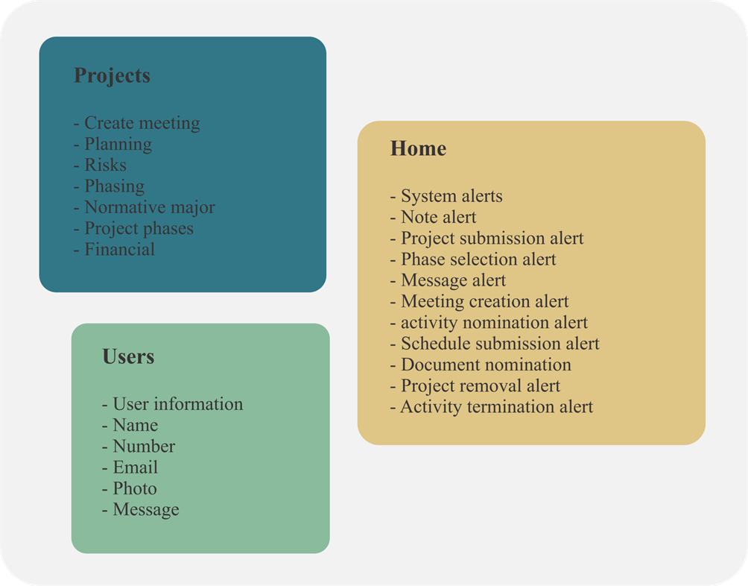

**Technical Requirements**

It is critical to understand the technologies that are being used in the project; this will help us determine what is required prior to constructing a website.

Web server, database, and language interpreter are the technologies to consider while starting started with a website.

Content and website administrators utilize a web browser to access a web-based GUI to complete their day-to-day job, and CMS must be installed on a web server.

To update templates, website logic, and execute updates or maintenance, website designers and developers need access to the server's files.

Linux Hosting can be used for self-installation, easy installation and complete support using cPanel at (Hosting.com.tr) website.

**Apache web server:** the HTTP web server Apache is still one of the most widely used web servers for serving web content. It doesn't matter if it's commercial or open source (Open platforms, 2012). Apache Web Server is a collaborative project from 1995 that provides open-source code for HTTP Web servers (Apache, n.d.).

**MYSQL Database:** MySQL is the most widely used database in the world, and it is used by some of the most well-known organizations online, like Facebook, Google, Amazon, and Yahoo (Henschen, 2011). Its remarkable combination of rapid SQL queries and open access to the source code has made it another success, following in the footsteps of Apache and PHP, with over 65 thousand downloads each day (My sql, n.d.).

**Instructor Technique for activate our project**

First step:-

Install XAMPP

Second step:-

Activated the two model Apache and My SQL

Third step :-

Open any browser and write localhost/final